**UID LAB EXP 6**  
**UI Design Lifecycle Using RAD Model for an Amazon-Style Shopping Interface**  
**Name:** Saravanan B  
**Reg. No.:** 230701283

**UI Design Lifecycle Using RAD Model**

**Project Title:** *“Amazon-style” – E-Commerce UI Simulation*

**Aim**

To apply the Rapid Application Development (RAD) model for designing a simplified Amazon-style e-commerce interface. The objective is to develop a functional and visually navigable UI through rapid prototyping and iterative feedback.

**Simulating the Lifecycle Stages Using the RAD Model**

**1. Requirements Planning**

**Objective:**  
Identify key user needs and UI components to simulate an e-commerce shopping flow.

**Feature Breakdown:**

* **Search Section:** Input area for searching products.
* **Offer Banner:** Highlights special deals (e.g., Great Indian Sale).
* **Category Navigation:** Buttons for Daily Essentials, Fashion, Electronics, etc.
* **Product Listing:** Displays featured products with image, name, price, and action buttons.
* **Checkout Form:** Collects user details and payment method.
* **Order Confirmation:** Confirms product purchase with summary

**2. User Design (Prototyping)**

**Tool Used:**  
PowerPoint/Figma/Axure (as applicable – visual mockup created)

**Page Breakdown:**

**a. Homepage**

* Top: Branding and search bar
* Center: Promotional banner (Great Indian Festival)
* Button: “Sign In” for login
* Categories displayed as clickable buttons: Fashion, Electronics, Books, etc.

**b. Product Detail Page**

* Product image (watch)
* Product information: Title, price, rating
* Action buttons: “Buy Now”, “Add to Cart”

**c. Checkout Page**

* Input fields: Name, Phone, Email, Address, Payment Mode
* Order Summary displayed with image and price

**d. Order Confirmation Page**

* Confirmation stamp (green "CONFIRMED")
* Product image
* Message: “Order Confirmed”

**Interactions Simulated:**

* Clickable categories and buttons
* Navigation between product detail, checkout, and confirmation pages

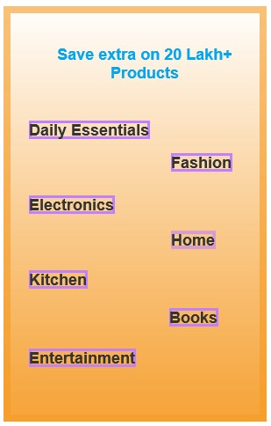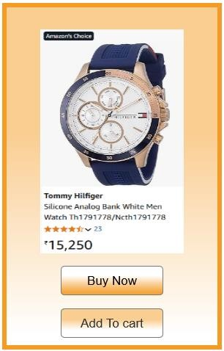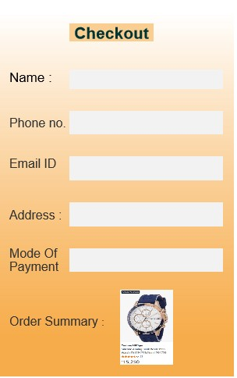

**3. Construction**

**Prototyping Approach:**

* Created visual UI flow in PowerPoint or prototyping tool
* Used real product mockups (e.g., Tommy Hilfiger Watch)
* Maintained color hierarchy and contrast for visual clarity
* Layout aligned for both mobile and desktop formats

**Simulated Functionalities:**

* Product selection
* Adding to cart and checkout process
* Order confirmation with receipt

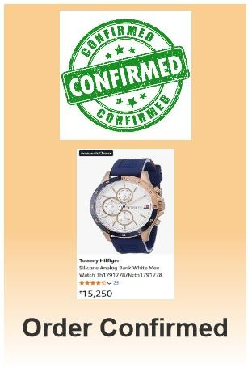

**4. Cutover (Testing and Feedback)**

**Testing Approach:**

* Conducted peer review with test users
* Focus on:
  + Clarity of navigation
  + Visual consistency
  + Field input ease

**Feedback Iteration:**

* Enlarged font for clarity
* Aligned form elements properly
* Improved button visibility with color contrast

**Conclusion**

This project demonstrates the use of the RAD model in crafting an Amazon-inspired e-commerce UI. The visual design captures the essential flow of an online purchase journey—from search and product selection to checkout and order confirmation—using rapid prototyping methods for efficiency and adaptability.